Multi-Agent Software Development Team
An Autonomous, Governable Multi-Agent Platform for End-to-End Software Delivery

Project Description:
The Multi-Agent Software Development Team is a Generative AI-based, agentic orchestration platform built with Python, LangGraph-style state-machine orchestration, multi-provider LLM APIs (Google Gemini, OpenAI, and Anthropic, with a deterministic offline fallback engine), a sandboxed test-execution environment, Git-based version control, and Streamlit, to automate the end-to-end software development lifecycle from a single natural-language requirement. Building a working software prototype normally demands coordinated effort across several distinct disciplines — requirements analysis, architecture design, implementation, security review, code review, static analysis, testing, debugging, documentation, and release packaging — a multi-stage process that is slow, inconsistent, and error-prone when performed manually or handed to a single generalized assistant. The platform allows an operator to submit one software requirement in natural language, after which a coordinated pipeline of ten specialized AI agents plans, implements, verifies, repairs, documents, and version-controls a working prototype with no further manual intervention, while still offering optional human checkpoints, live observability, and automatic escalation whenever the system cannot resolve a problem on its own.
The system is organized as a single, typed orchestration graph: a Requirements Analyst agent structures the raw requirement (after an automated clarification pass resolves ambiguity); an Architecture agent designs the module boundaries and interfaces; a Code Generation agent implements every module; a Security Review agent and a Code Review agent audit the implementation in parallel stages; a Static Analysis gate lints and type-checks the code before it is ever executed, looping back to Code Generation on failure; a Test & Verification agent synthesises and executes a Pytest suite inside an isolated sandbox with per-module coverage reporting; a Bug-Fix Loop agent iteratively patches failing code and always re-runs the full regression suite, escalating to a human operator if a failure persists beyond the configured retry limit; and a Documentation agent — optionally paired with a DevOps agent — compiles the finished requirements, architecture, code, and test results into project documentation, a CI/CD scaffold, and a fully versioned Git history. A dark-themed Streamlit control-room frontend drives this pipeline, exposing every one of the ten extended capabilities as independently toggleable feature flags, and rendering the results across a twelve-tab results explorer.

SCENARIOS
- Scenario 1 — Fully Autonomous Pipeline: The operator submits a requirement with require_approval left off. The Clarification agent first checks the requirement for gaps and, if it is already clear, the pipeline runs end-to-end without stopping: Requirements → Architecture → Code Generation → Security Review → Code Review → Static Analysis → Test Execution → (Bug-Fix Loop, if needed) → Documentation. Every stage commits its artefacts to Git, logs an audit entry, and records a trace of its duration, token estimate, and cost. The operator is returned a COMPLETED (or ESCALATED) pipeline state with the full project directory, source files, tests, reports, and commit history.
- Scenario 2 — Human-in-the-Loop (HITL) Governed Pipeline: The operator submits a requirement with require_approval=True. The pipeline pauses after Requirements, again after Architecture, and again after Code Generation, presenting each artefact through the Streamlit approval-gate panel. At each gate a reviewer can approve_and_continue() to move forward, request_changes() to send the artefact back with written feedback, or reject_and_stop() to halt the pipeline entirely — every decision is timestamped and appended to an approval_history audit trail before the pipeline resumes.
- Scenario 3 — Clarification, Bug-Fix Recovery, and Escalation: When the submitted requirement is ambiguous, the Clarification agent generates up to five targeted questions and pauses the pipeline (PAUSED_FOR_CLARIFICATION) until the operator answers them through submit_clarification_answers(). Later, if the generated code fails its test suite, the Bug-Fix Loop agent patches the code and the full regression suite is re-run automatically; if the same failure signature persists beyond the configured retry limit, the pipeline transitions to ESCALATED status, surfaces a diagnostic summary of the unresolved tests, and still proceeds to generate documentation.
Technical Architecture :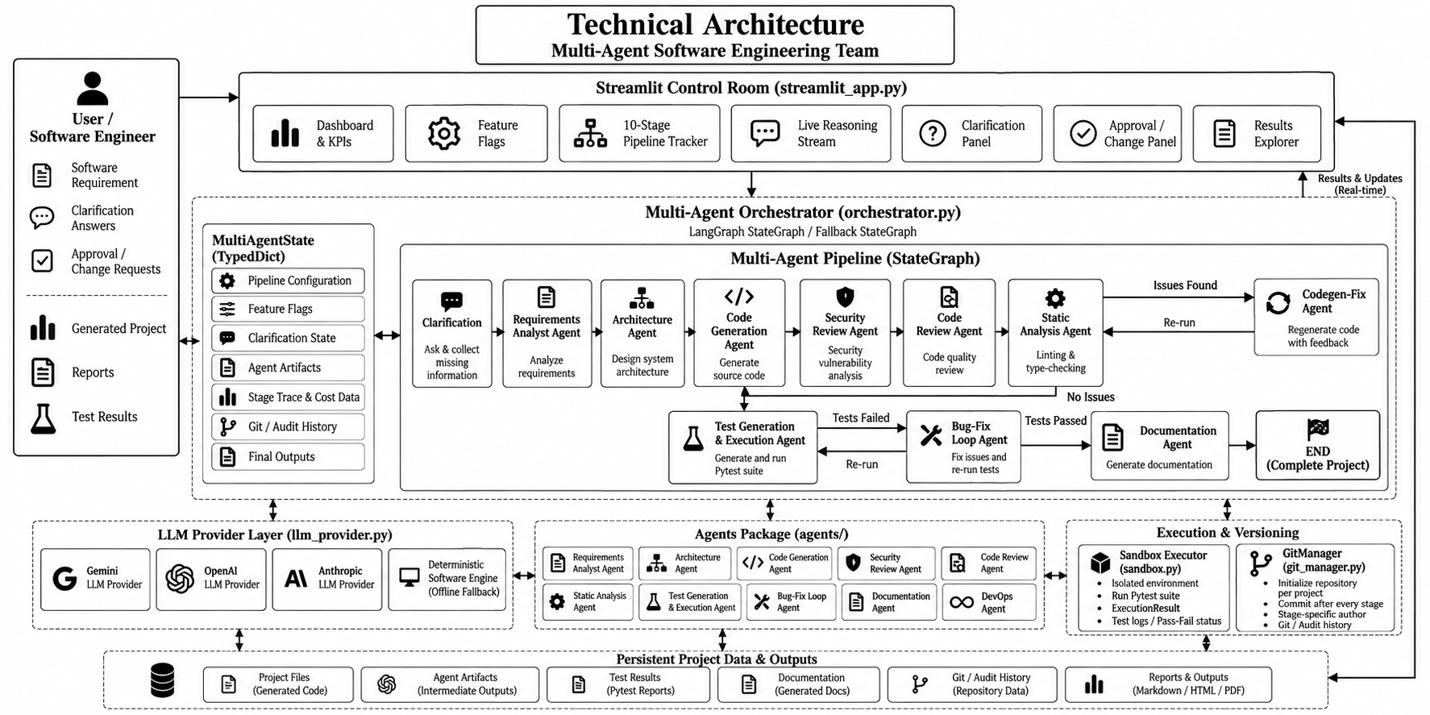
Pre-requisites :
- Python Programming Proficiency: Python Documentation
- LangGraph / State-Machine Orchestration: LangGraph Documentation
- Streamlit Framework Knowledge: Streamlit Documentation
- Google Gemini API Integration: Gemini API Documentation
- OpenAI API Integration: OpenAI API Documentation
- Anthropic API Integration: Anthropic API Documentation
- Automated Testing with Pytest: Pytest Documentation
- Code Coverage Reporting: pytest-cov Documentation
- Sandboxed / Subprocess Code Execution: Python subprocess Documentation
- Version Control with Git: Git Documentation
- Development Environment Setup: Python venv Guide

Project Workflow
Milestone 1: Provider Abstraction and Orchestration Architecture
- Activity 1.1: Design the multi-provider LLM abstraction (BaseLLMProvider) supporting Gemini, OpenAI, Anthropic, and a deterministic local fallback, with automatic provider selection through get_llm_provider().
- Activity 1.2: Design the typed pipeline state (MultiAgentState) capturing configuration, pipeline control, clarification data, every agent's artefacts, trace/cost totals, and the Git/audit history.
- Activity 1.3: Design FeatureFlags, a dataclass of ten independently toggleable capabilities with sensible always-on/opt-in defaults and all_on()/all_off() presets.
- Activity 1.4: Build the LangGraph StateGraph orchestration engine, including a dependency-free fallback implementation so the pipeline runs even without the langgraph package installed.
- Activity 1.5: Set up the Python development environment, virtual environment, and project structure (orchestrator.py, llm_provider.py, streamlit_app.py, an agents/ package, sandbox.py, git_manager.py).
Milestone 2: Core Agent Pipeline Development
- Activity 2.1: Implement the Clarification Loop — _generate_clarification_questions() prompts the LLM for up to five targeted questions in strict JSON, and clarification_node() pauses the pipeline only when genuine gaps are found.
- Activity 2.2: Implement requirements_node() — runs RequirementsAnalystAgent, writes REQUIREMENTS.md, and commits the specification to Git.
- Activity 2.3: Implement architecture_node() — runs ArchitectureAgent to produce a module-by-module blueprint, writes ARCHITECTURE.md, and commits the design.
- Activity 2.4: Implement codegen_node() — runs CodeGenerationAgent, validates each .py file's syntax and scans for stray f-string backslashes in _write_files() before anything touches disk, then commits.
- Activity 2.5: Implement review_node() — runs CodeReviewAgent to score the implementation out of 10, writes CODE_REVIEW.md, and commits the audit.
Milestone 3: Quality, Security, and Verification Gates
- Activity 3.1: Implement security_node() — runs SecurityReviewAgent to scan for hardcoded secrets, injection risks, unsafe eval/exec, and missing input validation.
- Activity 3.2: Implement the Static Analysis Gate — static_analysis_node() runs lint/type-check tooling, and route_after_static() sends failing code back to codegen_fix_node().
- Activity 3.3: Implement Test Execution with regression and coverage — test_node() always passes the full accumulated test suite, and _run_with_coverage() layers pytest-cov reporting on top.
- Activity 3.4: Implement the Bug-Fix Loop with escalation — bugfix_node() patches failing code each iteration; route_after_testing() tracks per-failure retry counts and escalates once a limit is exceeded.
- Activity 3.5: Implement Documentation and CI/CD generation — docs_node() runs DocumentationAgent, and, when enabled, DevOpsAgent scaffolds a GitHub Actions workflow, requirements.txt, and a Dockerfile.
Milestone 4: Human-in-the-Loop Governance and Observability
- Activity 4.1: Implement HITL approval gates — approve_and_continue(), request_changes(), and reject_and_stop() manage each transition and append to approval_history.
- Activity 4.2: Implement the Pipeline Trace & Cost Dashboard — StageTrace records duration, a token estimate, and a cost estimate per stage.
- Activity 4.3: Implement the Live Agent Reasoning Stream — a thread-safe stream_emit()/stream_drain() queue.
- Activity 4.4: Integrate Git version control — GitManager commits the artefacts of every stage under a stage-specific author identity.
- Activity 4.5: Implement state persistence and resumability — save_state()/load_state() serialise the full pipeline state to state.json.
Milestone 5: Streamlit Frontend Development
- Activity 5.1: Build the application shell and mission control — page configuration and the branded sidebar with live status/KPIs.
- Activity 5.2: Build the pipeline stepper and interactive panels — a ten-stage visual tracker plus live-stream, clarification, escalation, and approval-gate panels.
- Activity 5.3: Build the sidebar controls — an LLM provider selector and ten feature-flag toggles.
- Activity 5.4: Build the twelve-tab results explorer.
- Activity 5.5: Apply visual styling and build export tooling — dark control-room theme, ZIP export, GitHub-publish modal.
Milestone 6: Deployment
- Activity 6.1: Prepare the local environment — virtual environment and dependency installation.
- Activity 6.2: Configure LLM provider credentials as environment variables.
- Activity 6.3: Run the application locally with streamlit run streamlit_app.py.
- Activity 6.4: Submit a sample requirement and validate the full pipeline end-to-end.
Milestone 1: Provider Abstraction and Orchestration Architecture
Activity 1.1: Multi-Provider LLM Abstraction
- Provides a single generate(system_prompt, user_prompt, temperature, json_output) interface implemented by GeminiLLMProvider, OpenAILLMProvider, and AnthropicLLMProvider.
- get_llm_provider() auto-detects the active provider by priority: an explicitly requested provider_type, then GEMINI_API_KEY, OPENAI_API_KEY, or ANTHROPIC_API_KEY environment variables, then the deterministic fallback.
- DeterministicSoftwareEngineProvider inspects the system prompt to identify which agent role is calling it, then returns syntactically valid, schema-correct JSON or runnable code tailored to that role, so the entire pipeline can run end-to-end with zero external API keys.
- Provider switching requires no change to any node or agent.
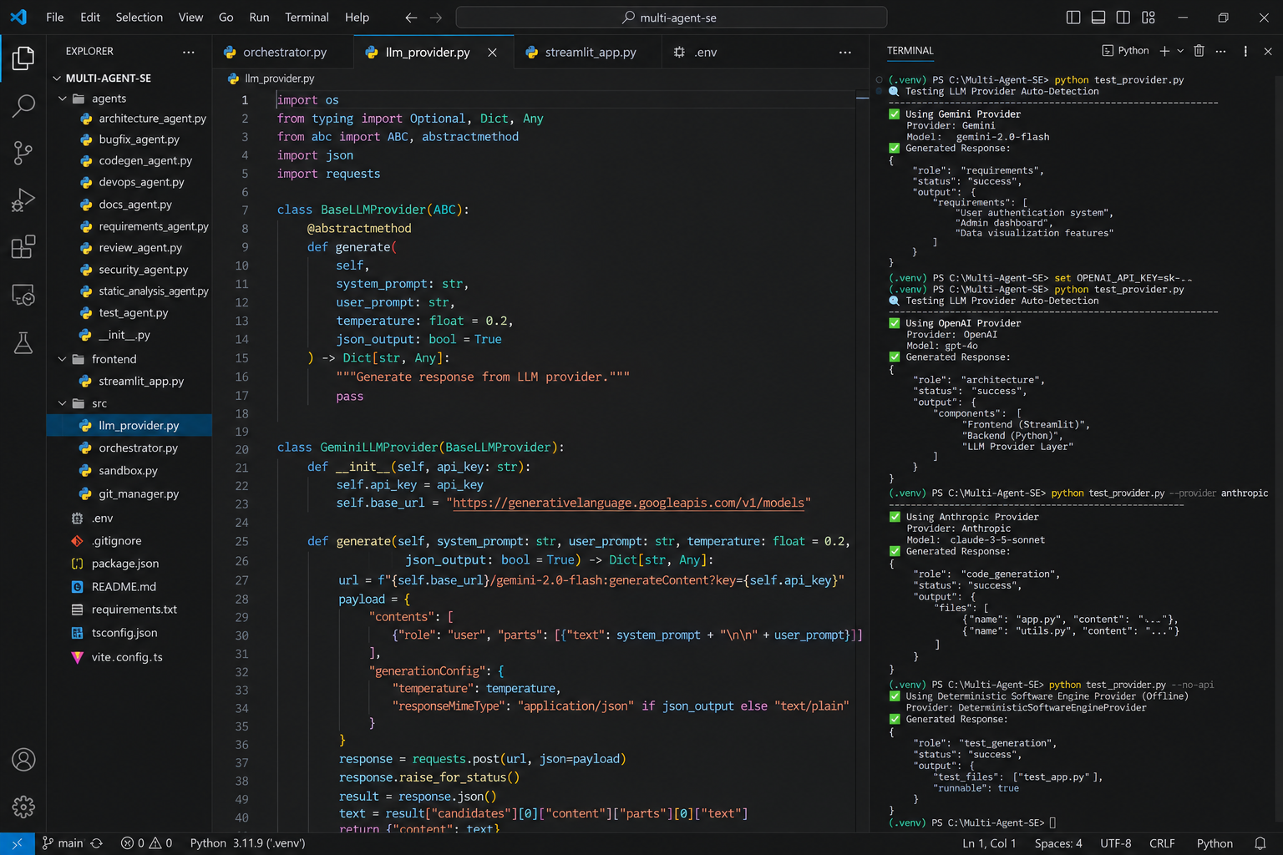

Activity 1.2: Typed Pipeline State
- MultiAgentState groups configuration, pipeline control, clarification data, per-agent artefacts, trace/cost totals, and Git/audit history in one structure.
- save_state()/load_state() serialise this structure to state.json, giving every pause point a durable resume point.

Activity 1.3: Feature Flags
- FeatureFlags is a dataclass of ten toggles: clarification_loop (always on), security_review, static_analysis, bugfix_escalation, regression_testing, coverage_reporting, and trace_dashboard (on by default), plus hitl_checkpoints, live_stream, and cicd_scaffolding (opt-in).
- to_dict()/from_dict() persist flags inside the pipeline state; all_on() and all_off() provide quick presets.
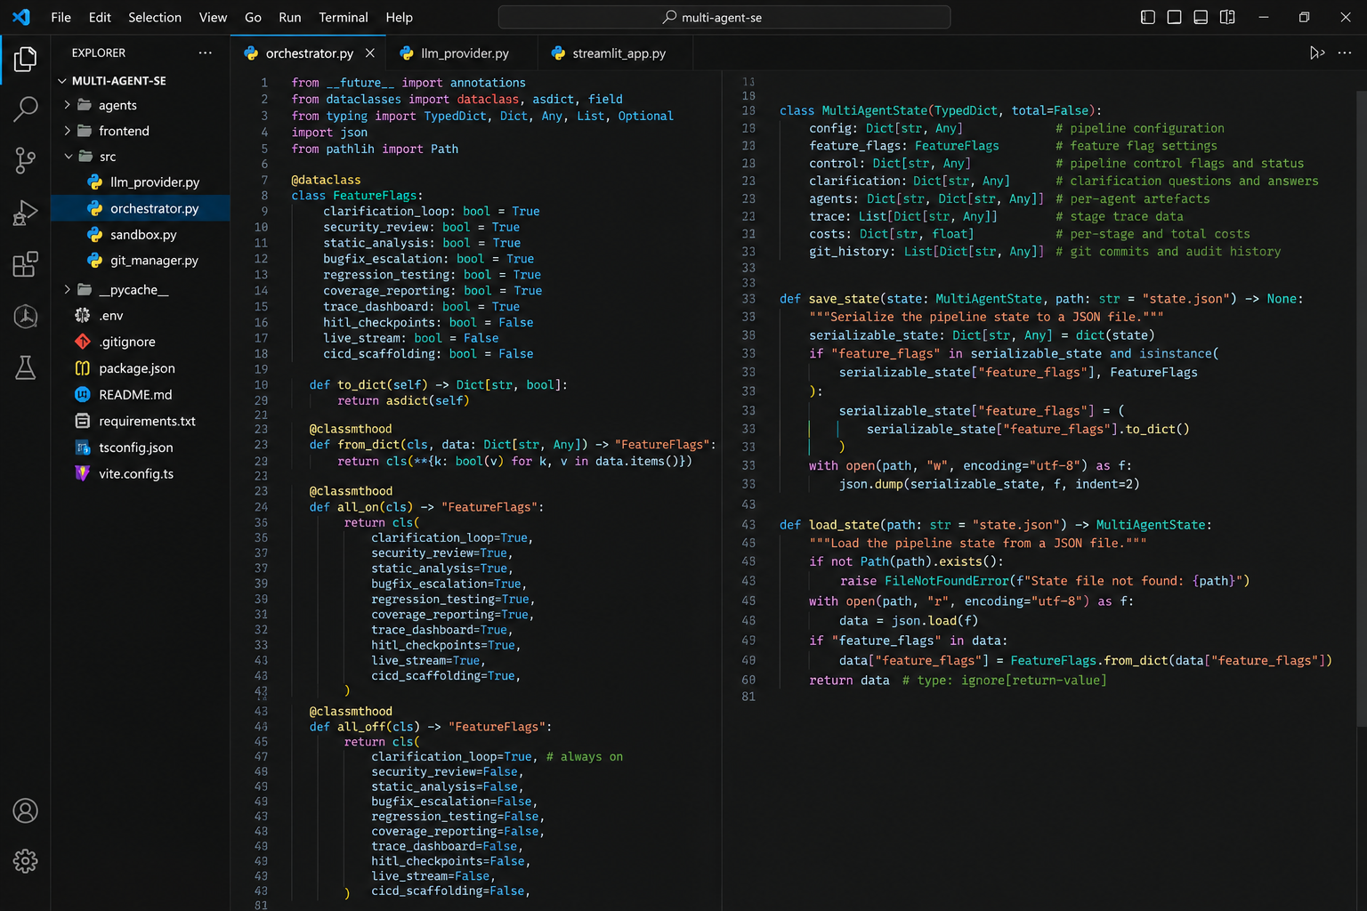
Activity 1.4: Orchestration Engine
- When langgraph is available, MultiAgentOrchestrator._build_graph() uses its StateGraph, START, and END to wire eleven nodes and two conditional routers.
- When langgraph is not installed, an equivalent StateGraph/START/END is implemented locally in the same module, so the orchestrator degrades gracefully instead of failing to import.
Activity 1.5: Development Environment Setup
- Install Python 3.9+ and pip; create an isolated virtual environment.
- Install core dependencies — Streamlit, an LLM SDK or requests/urllib, pytest, and optionally pytest-cov/langgraph — as pinned in requirements.txt.
- Lay out the project as orchestrator.py, llm_provider.py, streamlit_app.py, an agents/ package, sandbox.py, and git_manager.py.
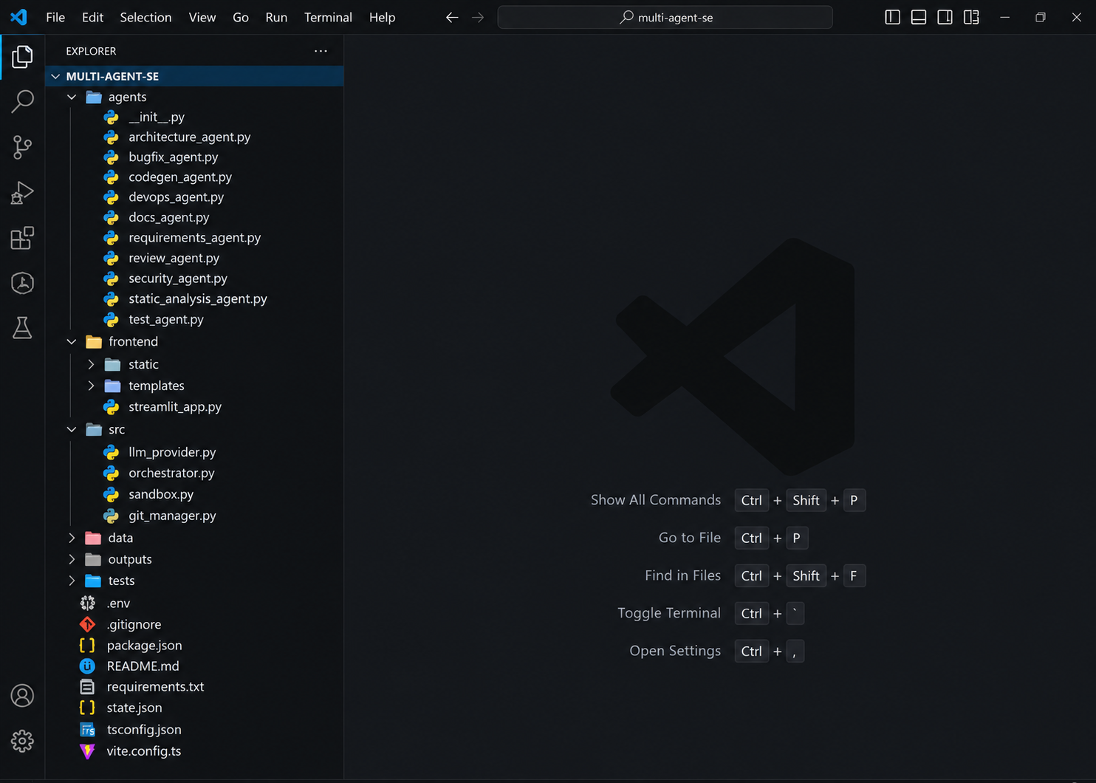

Milestone 2: Core Agent Pipeline Development

Activity 2.1: Clarification Loop
- _generate_clarification_questions() sends a strict-JSON prompt asking the LLM for up to five genuine ambiguities, categorised as scope, constraint, data_model, or edge_case.
- If no questions are returned, clarification_answered is set True immediately and the pipeline proceeds without interruption.
- If questions are returned, pipeline_status becomes PAUSED_FOR_CLARIFICATION and the state is persisted; submit_clarification_answers() records each answer and resumes the pipeline from Requirements.
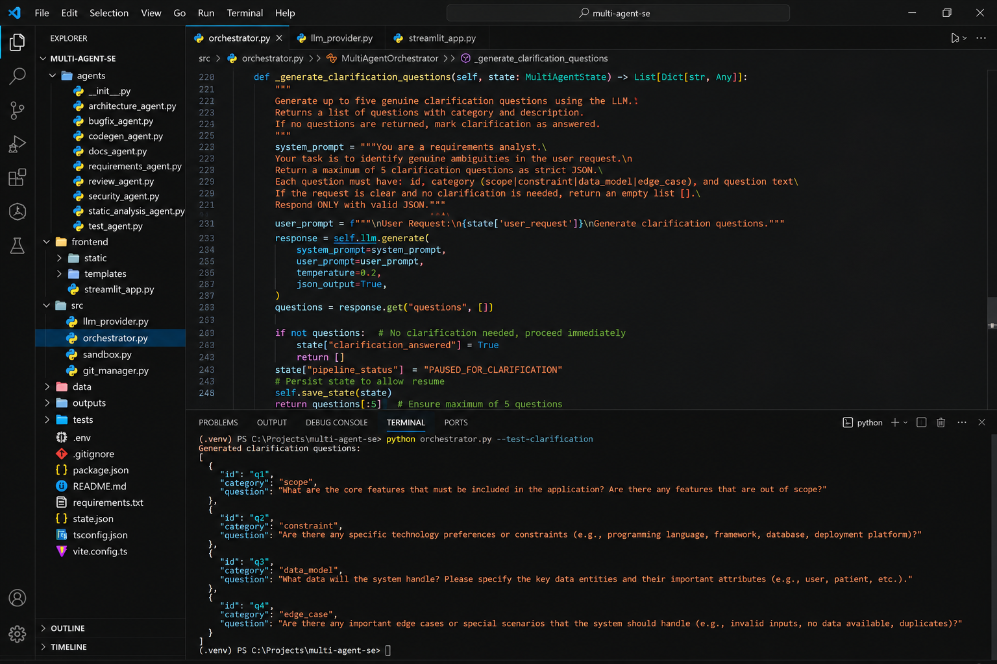
Activity 2.2: Requirements Analyst Agent
- requirements_node() appends any answered clarification Q&A pairs to the raw requirement before calling RequirementsAnalystAgent.run().
- The resulting RequirementsDocument is written to REQUIREMENTS.md and committed to Git.

Activity 2.3: Architecture Agent
- architecture_node() runs ArchitectureAgent.run() to produce a system overview, design patterns, data flow, and a per-module breakdown.
- The blueprint is written to ARCHITECTURE.md and committed to Git.

Activity 2.4: Code Generation Agent
- codegen_node() runs CodeGenerationAgent.run() to produce a {file_path: source_code} mapping.
- _write_files() compiles every .py file with Python's own compile() before writing it to disk and raises on syntax errors, and separately flags a common stray-backslash pattern inside f-strings.
- Every generated file set is committed to Git under the CodeGen-Agent identity.

Activity 2.5: Code Review Agent
- review_node() runs CodeReviewAgent.run() to produce an overall score out of 10 and a structured issue list (severity, file, description).
- The findings are written to CODE_REVIEW.md and committed.
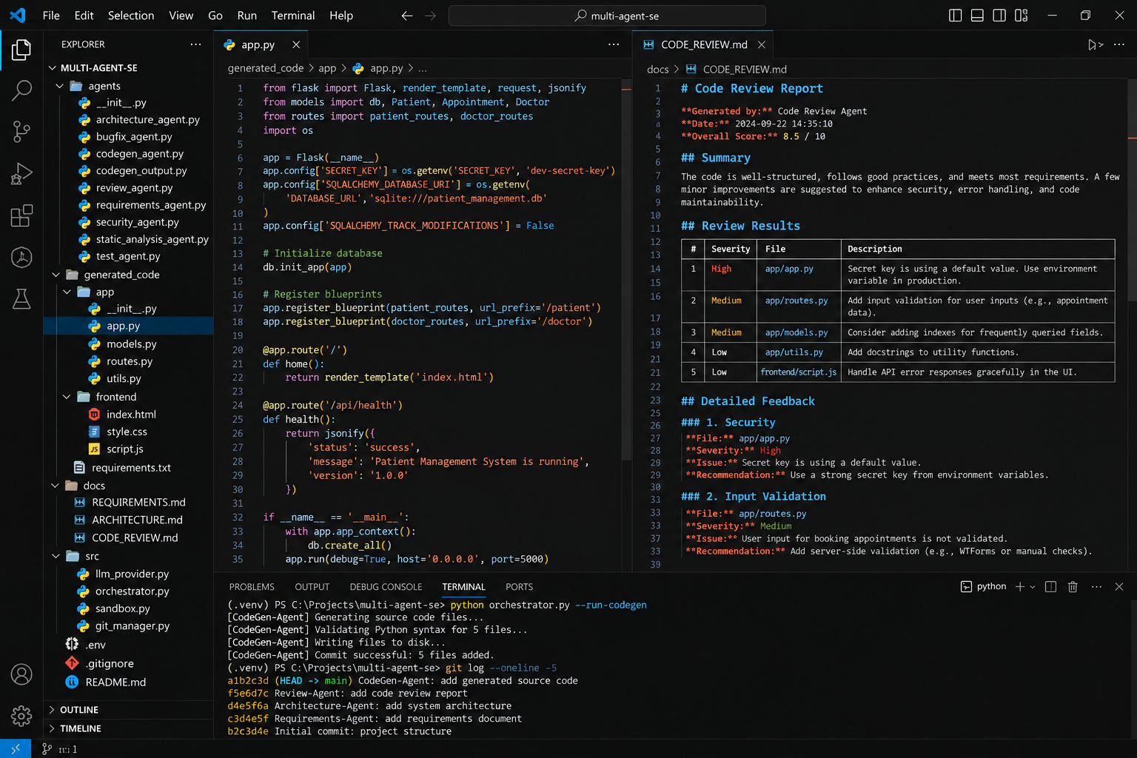

Milestone 3: Quality, Security, and Verification Gates
Activity 3.1: Security Review
- security_node() (skippable via the security_review flag) runs SecurityReviewAgent.run() over the generated code to detect hardcoded secrets, injection risks, unsafe eval/exec usage, and missing input validation.
- The result records a risk level, an overall score out of 10, and a list of findings.

Activity 3.2: Static Analysis Gate
- static_analysis_node() runs StaticAnalysisAgent (lint and type-check tooling) with a bounded timeout.
- route_after_static() inspects the passed flag: on failure it routes to codegen_fix_node(), which re-invokes code generation with the specific violations supplied as feedback, then re-enters the same gate.
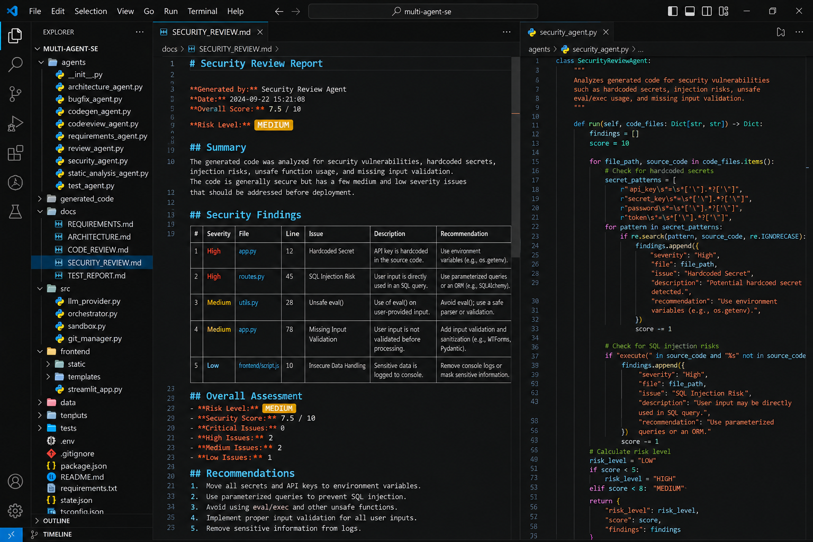
Activity 3.3: Test Execution, Regression, and Coverage
- test_node() runs TestGenerationExecutionAgent.run() together with SandboxExecutor, always supplying the previously accumulated test files so the full suite is exercised.
- _run_with_coverage() writes both code and tests into a temporary directory, strips API keys from the subprocess environment, detects pytest-cov, and parses per-module and total coverage percentages, flagging any module below an 80% threshold.

Activity 3.4: Bug-Fix Loop with Escalation
- route_after_testing() sends a failing state to bugfix_node(), which calls BugFixLoopAgent.run() to produce a patched file set.
- bugfix_per_test_retries tracks how many times each distinct failure signature has recurred; if any signature exceeds max_iterations the pipeline sets pipeline_status to ESCALATED and attaches an escalation_info payload for the operator.
Activity 3.5: Documentation and CI/CD Generation
- docs_node() runs DocumentationAgent.run() to produce a README and a machine-readable build summary.
- When cicd_scaffolding is enabled, DevOpsAgent.run() additionally produces a GitHub Actions workflow, a requirements.txt, and a Dockerfile.
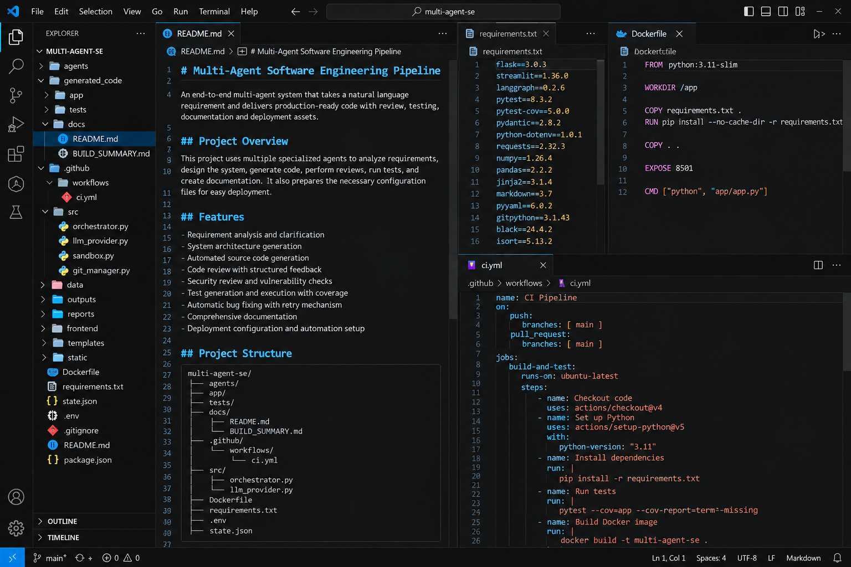

Milestone 4: Human-in-the-Loop Governance and Observability
Activity 4.1: HITL Approval Gates
- run_pipeline(require_approval=True) pauses after clarification and requirements, then Architecture, then Code Generation.
- request_changes() and reject_and_stop() give the reviewer the option to send an artefact back with feedback or halt the pipeline outright; every action is timestamped and appended to approval_history.
Activity 4.2: Pipeline Trace and Cost Dashboard
- Every node that completes work calls _add_trace() to append a StageTrace — stage, agent, start/end time, duration, an estimated token count, and an estimated cost at a $0.0004-per-1,000-token baseline.
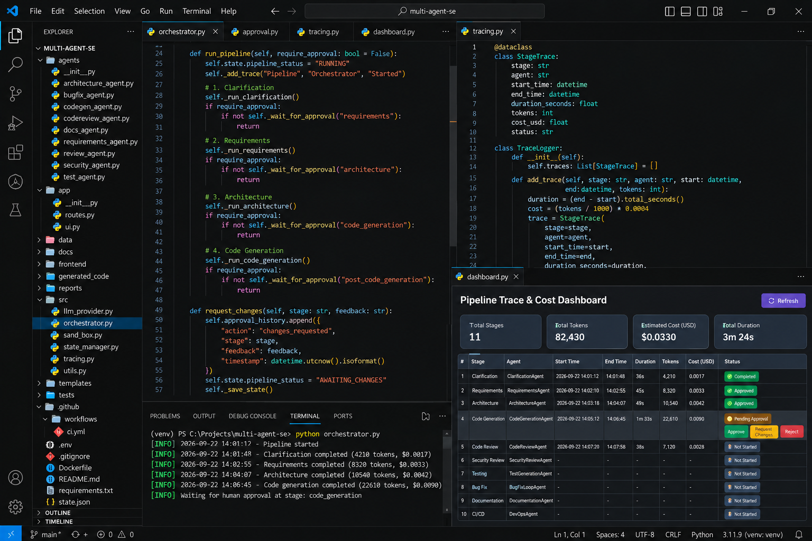
Activity 4.3: Live Agent Reasoning Stream
- A module-level, bounded queue.Queue receives short reasoning snippets from every node via stream_emit(); stream_drain() empties the queue for the UI to render.

Activity 4.4: Git Version Control Integration
- GitManager initialises a repository in the project directory at pipeline start and commits after every stage under a distinct, stage-appropriate author identity.

Activity 4.5: State Persistence and Resumability
- save_state() writes the full MultiAgentState to state.json after every pause point; load_state() restores it for a later session.
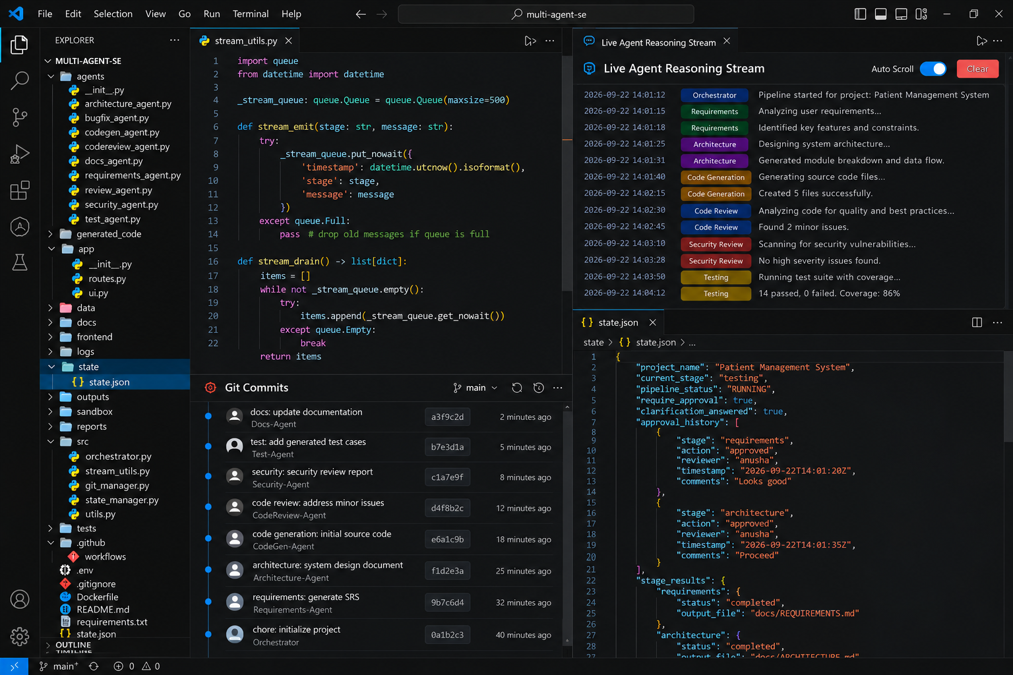

Milestone 5: Streamlit Frontend Development
Activity 5.1: Application Shell and Mission Control
- The page is configured with a wide layout and an expanded sidebar; render_sidebar() shows a live status chip, current stage, and a KPI list.
Activity 5.2: Pipeline Stepper and Interactive Panels
- render_stage_pipeline() visualises all ten pipeline stages; render_live_stream() polls stream_drain().
Activity 5.3: Provider and Feature-Flag Controls
- The sidebar exposes an LLM-provider radio (deterministic / Gemini) and ten labelled toggles.
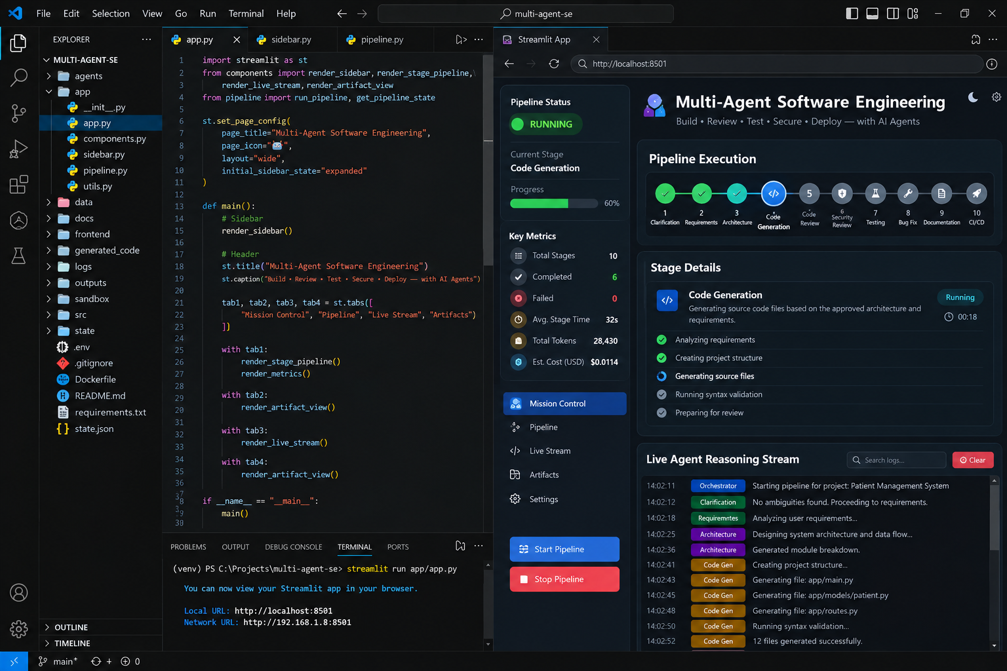
Activity 5.3: Provider and Feature-Flag Controls
- The sidebar exposes an LLM-provider radio (deterministic / Gemini) and ten labelled toggles.
Activity 5.4: Multi-Tab Results Explorer
- Twelve tabs — Source Code, Requirements, Architecture, Security, Code Review, Static Analysis, Pytest Sandbox, Git Commits, CI/CD Scaffold, Documentation, Trace Dashboard, and Audit Trail.
Activity 5.5: Visual Styling and Export Tooling
- A dark, teal-accented custom-CSS theme; export_zip_bytes() packages the project for download; render_github_modal() publishes to GitHub.

Milestone 6: Deployment
Activity 6.1: Prepare the Local Environment
- Create a virtual environment: python -m venv venv, then activate it.
- Install dependencies: pip install -r requirements.txt.
Activity 6.2: Configure LLM Provider Credentials
- Set GEMINI_API_KEY, OPENAI_API_KEY, and/or ANTHROPIC_API_KEY as environment variables; with none set, the platform runs entirely on the deterministic fallback engine.
Activity 6.3: Run the Application
- Start with streamlit run streamlit_app.py and confirm the sidebar status panel, feature-flag toggles, and provider selector render correctly.
Activity 6.4: Local Testing and Verification
- Submit a sample requirement and confirm the clarification loop, all twelve result tabs, the HITL approval flow, the bug-fix/escalation path, the exported ZIP, and the Git commit history all behave as expected.
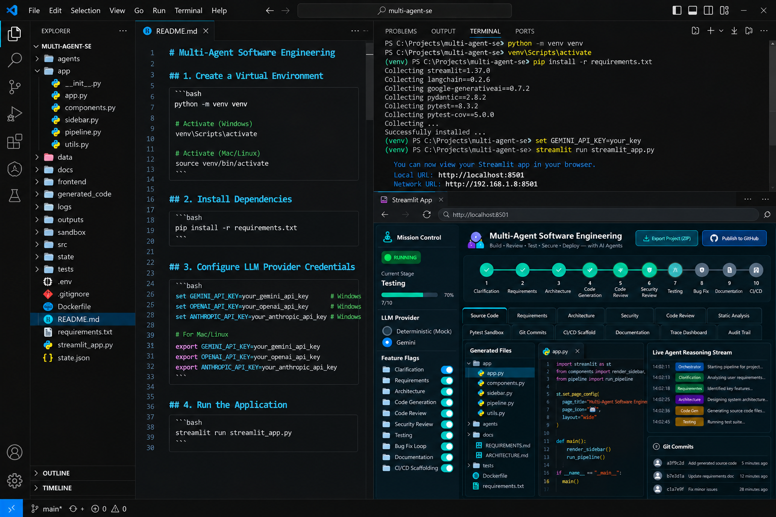

Exploring the Application's Interfaces
- Mission Control Dashboard: The main workspace showing pipeline status, live KPIs, feature-flag toggles, and the LLM provider selector.
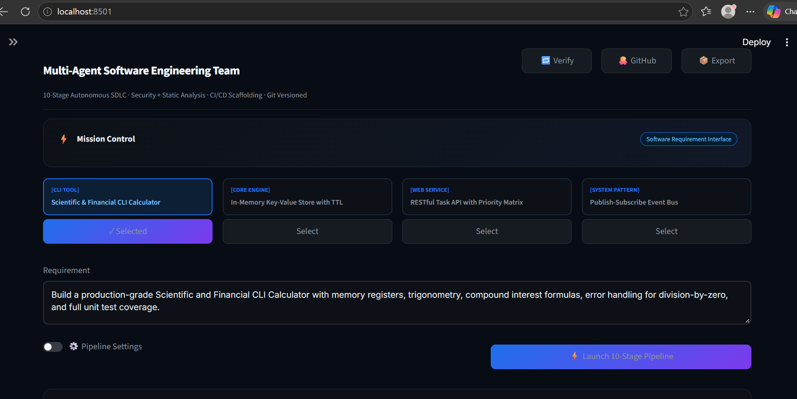
- 10-Stage Pipeline Tracker: A visual stepper showing progress through Clarification, Requirements, Architecture, Code Generation, Security, Review, Static Analysis, Testing, Bug-Fix, and Documentation.
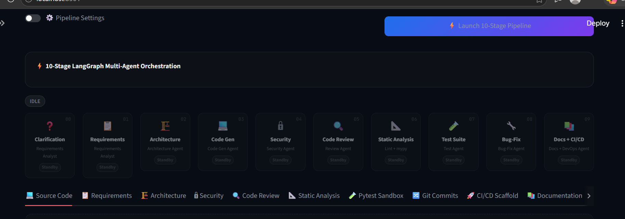
- Results Explorer: The twelve-tab view presenting source code, requirements, architecture, security findings, review scores, static analysis results, test/coverage output, Git history, CI/CD scaffold, documentation, trace dashboard, and audit trail.
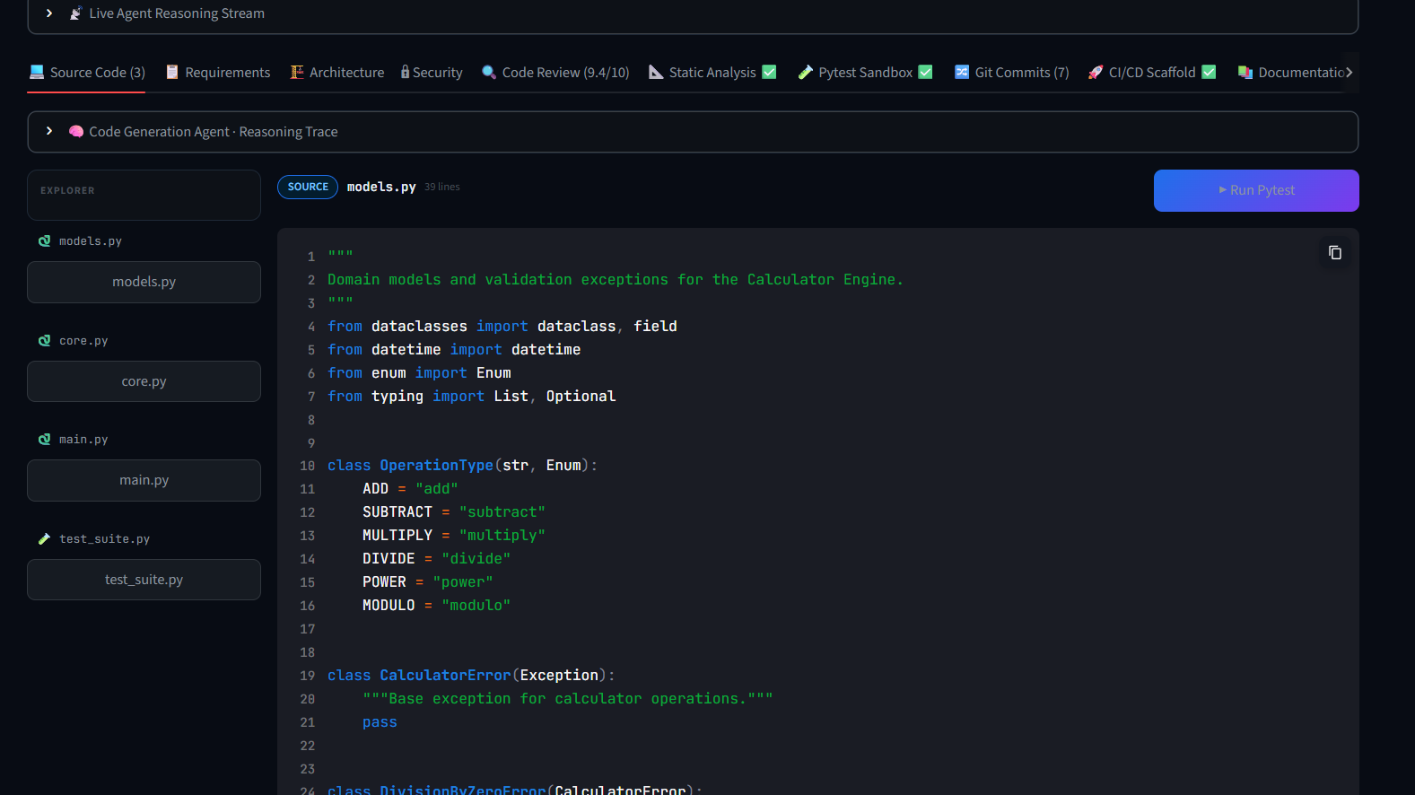

Advantages
- Multi-provider LLM resilience: the platform auto-detects Gemini, OpenAI, or Anthropic credentials and falls back to a deterministic offline engine, so the pipeline always produces a working result, even with no API key configured.
- Never-break orchestration: a dependency-free fallback StateGraph keeps the pipeline runnable even when the optional langgraph package is not installed.
- Fully auditable pipeline: every stage produces a trace entry, an audit-log entry, and a Git commit.
- Composable feature flags: ten independent capabilities can be turned on or off per run without touching code.
- Full-suite regression safety: every bug-fix iteration re-runs the entire accumulated test suite rather than only the previously failing test.
- Escalation safety valve: a retry-limited bug-fix loop escalates to a human operator with a concrete diagnostic summary instead of looping indefinitely.
- Human-in-the-loop governance: optional approval gates after Requirements, Architecture, and Code Generation, each with a full, timestamped approval history.
- Pre-execution validation: generated Python files are syntax-compiled and scanned for stray f-string backslashes before they are ever written to disk.
- Live observability: a real-time agent reasoning stream and a per-stage token/cost dashboard.
- Ready for hand-off: on-demand CI/CD scaffolding, a downloadable project ZIP, and a Git-ready commit history.

Limitations
- Local, file-based state: pipeline state persists to a local state.json rather than a shared database, limiting concurrent multi-user or distributed use.
- Deterministic fallback is a stand-in: the offline DeterministicSoftwareEngineProvider produces template- and keyword-driven code and documents, not true generative reasoning, when no external API key is configured.
- Approximate cost accounting: token and cost estimates are derived from reasoning-text length rather than an actual provider tokenizer.
- Optional coverage dependency: per-module coverage reporting depends on pytest-cov being installed and degrades to an "unknown" marker when it is not.
- Single local repository per project: no built-in push to a remote Git host beyond the optional GitHub-publish modal.
- Process-local live stream: the reasoning-stream queue is an in-process structure, not shared across multiple application instances or worker processes.
- No automated benchmark harness: there is no built-in suite scoring end-to-end pipeline output against a labelled ground truth.

Future Enhancements
- Persistent, database-backed pipeline history: store pipeline runs, approvals, and artefacts centrally for multi-user auditability.
- Tokenizer-accurate cost accounting: replace the character-based token estimate with each provider's real tokenizer.
- Native remote Git hosting: extend beyond the local repository and GitHub modal to first-class push/PR automation.
- Pluggable static analysis and security tooling: allow additional linters, type-checkers, and security scanners to be composed per project.
- Parallelised code generation: generate independent modules concurrently for larger prototypes.
- Configurable retry and escalation policy: expose retry limits, backoff, and escalation thresholds directly in the UI.
- Additional and local model support: add further hosted providers and locally hosted open-weight models.
- Role-based multi-user access: extend HITL approval gates with reviewer roles and permissions.

Conclusion
The Multi-Agent Software Development Team is a modular, Generative AI-based orchestration platform built with Python, a LangGraph-style state-machine engine (with a dependency-free fallback), multi-provider LLM clients, an isolated test-execution sandbox, and a fully instrumented Streamlit control room. It converts a single natural-language requirement into a structured specification, an architectural blueprint, reviewed and security-scanned implementation code, a passing and regression-tested Pytest suite, and complete project documentation — all version-controlled in Git and ready for hand-off. The project — spanning ten composable extended capabilities, autonomous and human-in-the-loop operating modes, a retry-limited bug-fix loop with operator escalation, and full pipeline observability — demonstrates how multi-agent orchestration, sandboxed verification, and governance-by-design can turn a traditionally manual, error-prone software delivery process into a faster, more consistent, transparent, and auditable engineering workflow. Future extensions could include database-backed pipeline history, tokenizer-accurate cost accounting, native remote Git hosting, and role-based multi-user governance.

